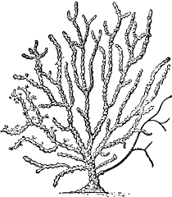
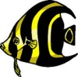
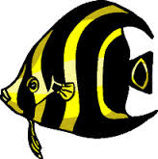
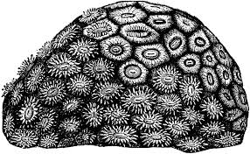

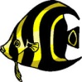
Essential Questions: What is a coral reef?
Where are coral reefs located?
Level 1 Tasks / Knowledge: Identification and Recall of Information
Click the Coral Reefs Link #1 on the webquest page.
Use the information on this site to answer the questions below.
Fill in the blank:

Coral Reefs may look like rocks, but they are actually _______________________________________________.

What are these organisms? _________________________________________________________________________.

Coral reefs are home to about _______% of all known marine life.

Fill in the pie chart to show this percentage.

(circle one): Does the coral reef eat?

Level 2 Tasks / Comprehension: Organization and Selection of Facts and Ideas
Click the Coral Reefs Link #2 on the webquest page.
Use the information on this site to answer the questions below.

Read the first paragraph. Identify the statement that best supports this sentence:
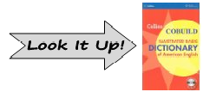
“Coral reefs are some of the most diverse ecosystems in the world.”

Diverse means

_____________________

______________________

a. Coral reefs are fragile.
b. A coral reef is usually found in shallow water.
c. There are three types of coral reefs: barrier, fringing, and atoll
d. A coral reef is a community of many different living organisms.

Read the three paragraphs about coral polyps. Then fill in the blanks below.
Word Bank
warm tentacles polyps plankton shallow tropical

Coral reefs are made up of many tiny animals called ______________. A ring of ______________________________ surround around a central opening or mouth. They use these long arms to __________________ their prey which is called ________________.
Coral reefs are found all over the world in ________________ areas. They mostly live in _______________, __________________ waters.
Level 3 Task / Application: Use of Facts, Rules, and Principles
Click the Coral Reefs Link #3 on the webquest page.
Use the information on this site to answer the questions below.

Coral reefs are very fragile. Circle the conditions that coral reefs need to survive:
warm water shade shallow water murky water clear water sunlight cold water fresh water deep water salt water
Explain what would happen if these conditions were to change. _________________________________
_____________________________________________________________________________________
_____________________________________________________________________________________
_____________________________________________________________________________________
_____________________________________________________________________________________
_____________________________________________________________________________________
_____________________________________________________________________________________

Level 4 Task / Analysis: Separating a Whole into Component Parts

View the slide show on the Coral Reefs webquest page.
Watch the videos in the Coral Reefs section of the webquest.
Search the internet to find out what coral reefs contain.
Fill in the blanks and then add information to complete the chart.

__________Things __________________Things

Plants ______________

Level 5 Task / Evaluate: Developing Opinions, Judgments, or Decisions
Click the Coral Reefs Link #4 on the webquest page.
Use the information on this site to answer the questions below.
Coral reefs are important marine habitats. This website explains five reasons that coral reefs are important. Read each reason and choose the one that you think is most important. Explain why you think this.

The most important reason that I think coral reefs are important is
_____________________________________________________________________________________
_____________________________________________________________________________________
_____________________________________________________________________________________
_____________________________________________________________________________________
_____________________________________________________________________________________
_____________________________________________________________________________________
_____________________________________________________________________________________
_____________________________________________________________________________________
_____________________________________________________________________________________

Level 6 Task / Synthesis: Combining Ideas to Form a New Whole
Choose one option: In your own words, create a poster to inform people about
- the importance of coral reefs to our world.
- what they can do to protect the coral reefs.

Map the World’s Coral Reefs
Directions:
Click the Coral Reef Habitat Map link on the webquest page.
Look at the map of Coral Reefs.
Use a red or pink marker to draw the habitats of coral reefs on the world map below.

